EENG 385 - Electronic Devices and Circuits

BJT Curve Tracer: Intro to MultiSim and the 555 Timer

Assembly Guide

# Assembly Guide for 555 Timer

This week, you will be soldering in the components associated with the POWER INPUT, 555 TIMER subsystems. These subsystems are names in Figure 9. It is important you do not solder in any of the other components in any of the other subsystems.

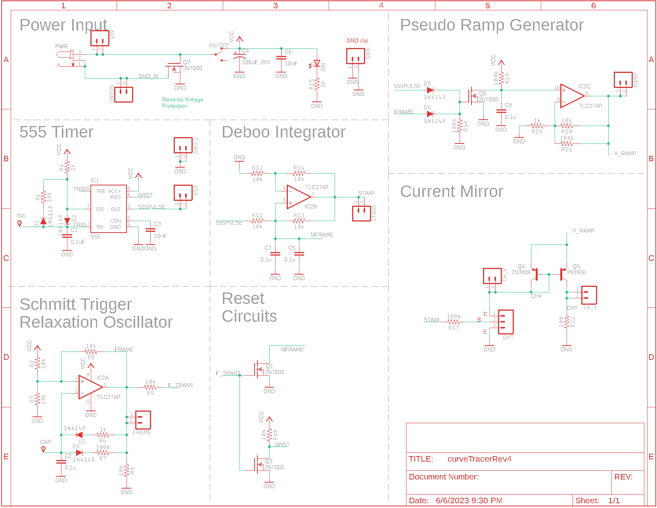

Figure : The schematic for the BJT curve tracer.

Most of the parts in this schematic have a designator and a value. The designator is a letter followed by a number. The designator letter tells you what type of part it is, “R” for resistor, “C” for capacitor, etc. The designator number tells you the index of that part in the entire collection of that part type.

The schematic in Figure 9 is the starting point for the layout shown in Figure 10. The physical position of the parts in the schematic and layout are unrelated. The schematic is an abstraction of the finished layout. The layout contains all the data used in the fabrication of the PCBs – the layout and the fabricated PCB are identical. Take a moment to look at the layout and compare it to the PCB for the curve tracer paying attention to the following bullet points.

* The green circles in Figure 10 are the layout are plated through holes in the PCB.
* The red lines in Figure 10 are traces (wires) on the top side of the PCB.
* The blue lines in Figure 10 are traces (wires) on the bottom side of the PCB.
* The grey lines and text in Figure 10 are white silk screen on the PCB.

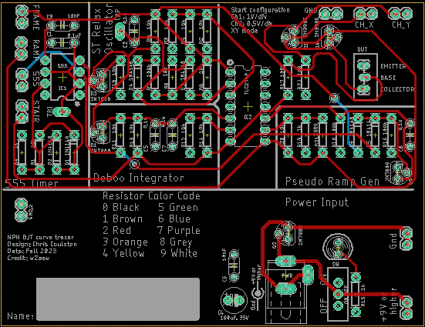

Figure : The layout of the BJT curve tracer.

The parts’ designators are important because they are the same in the schematic and the layout, providing you with a means to find a part. You should take a moment to notice parts which are logically related in the schematic are physically proximal in the layout.

Table : List of parts to be soldered into the PCB this week. Shaded cells are polarized components. Watch their orientation.

|  |  |
| --- | --- |
| POWER INPUT | 555 TIMER |
| PWR JACK | R4/1kΩ |
| ON/OFF | R1/10kΩ |
| C4/100µF | D1/1N4148 |
| C6/10nF | D2/1N4148 |
| LED1 | C1/0.1uF |
| R15/1kΩ | C3/10nF |
| Q2/2N7000 | IC1/555 |

## Polarized Parts

Most of the parts you will solder into the PCB can be installed in more than one way. Parts which must be installed in a correct orientation are called polarized. Polarized parts have some physical indication of their orientation and the silk screen will have some marking to show you where this physical indicator should be aligned. Let’s walk through all the polarized parts and how you will install them in the PCB.

* 555 Timer

The chip has a small round indentation in the corner which indicates Pin 1. This indentation should align with the white circle on the PCB silk screen.

* Diodes

The diodes are orange with a black stripe on one end. The black strip needs to align with the white stripe on the PCB silk screen. Caution, the diodes do not have a consistent orientation – pay close attention when stuffing parts into the PCB.

* Red 100 µF capacitors

The 100 µF capacitors have a white stripe which indicates the negative terminal. The negative terminal should align with the white bar (opposite the “+” bar) on the PCB silk screen.

* Green LED

The green LED has a flat side which indicates the negative terminal. This flat side should align with the flat side of the PCB silk screen.

* 2N7000 MOSFET

The 2N7000 MOSFET is a 3-pin device with an asymmetrical package. You will have to bend the center lead of the MOSFET to make it fit. Make sure to align the flat side of the MOSFET with the flat side of the silk screen.

## Test Points

Test points are electrical connections to important points in the circuit and frequently are the target of test and measurement equipment. All the test points on the BJT curve tracer PCB are formed with pairs of pads. You will connect together each pair of test-point pads with an approximately 1 cm long piece of wire – you can use the cut off end of resistor lead for this. You will do this for all the test-point connections listed below – their names are labeled in white silk screen on the PCB.

1. CH_X
2. CH_Y
3. GND (adjacent to CH_X and CH_Y)
4. 555PULSE
5. STAIR
6. FRAME
7. GND (adjacent to 555PULSE)
8. +9V or higher
9. GND (adjacent to +9V)

An example of a test point that you will solder in this lab is shown in Figure 11. Note the TRI pad does NOT get a test point soldered into it.

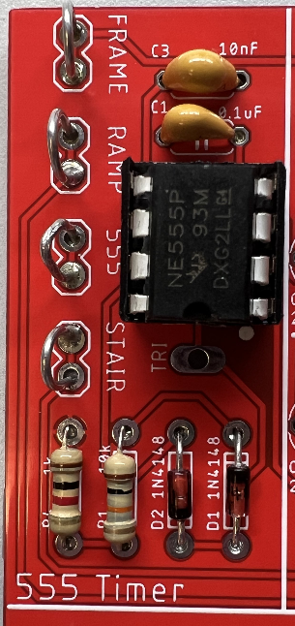

Figure : Wire loops soldered to the 555PULSE and FRAME test points. Do not solder in a wire loop to the TRI pin (just below the 555 timer).

# Assembly and Testing

Work on being patient with the heat from the solder iron soaking into the PCB pad and the part leads. Use a small dab of liquid solder on the tip of the iron to facilitate heat transfer. When everything is nice and hot, the small dab of solder will wick onto the PCB pad and component lead. When this happens, start to melt a small length (less than the join will need) into the interface between the iron tip and the component and PCB pad. Remove the solder while leaving the soldering iron tip in place to make a quick appraisal: Can the joint can take a little more solder? If so, add another little dab of solder. When done, remove the solder first, then the iron. When you get the knack of it, this should take about 5 seconds. Work on improving your work from last week – take your time.

You should take care and align the resistors so their gold tolerance bands all face the bottom of the board. This positioning will make it easier to read their values and compare your work to pictures of the assembled board. This aspect will be part of the grading rubric. Look at the **How To: Solder** posted on Canvas for recommendation on how to solder through hole parts.

## Assemble POWER INPUT Subsystem

You should start your soldering with the POWER INPUT subsystem. The subsystem will include the following parts. Note, please check the component values of your capacitor and resistor with the component tester on top of the blue cabinet in the North West corner of Brown 304.

1. 100µF capacitor – *POLARIZED!*
2. Green LED – *POLARIZED!*
3. 2N7000 MOSFET – *POLARIZED!*
4. 10nF capacitor
5. Power jack
6. ON/OFF slide switch
7. 1kΩ resistor
8. +9V or higher test point
9. GND test point

After you solder in all the components, test and correct any problems before soldering any other components.

## Test POWER INPUT Subsystem

1. Check the resistance between the “+9V or higher” and GND test points with the ON/OFF switch in the OFF position. You should get an overload condition on the DMM – there is essentially infinite resistance with the switch in the OFF position.
2. Check the resistance between the “+9V or higher” and GND test points with the ON/OFF switch in the ON position. You should get a very high resistance due to the revere voltage protection provided by the 2N7000.
3. Power up the BJT curve tracer:
   * Put the ON/OFF switch in the OFF position,
   * Apply power to the board either through your AC/DC converter or using the lab power supply through the “+9V or Higher” and GND in the Power Input area. DO NOT USE ANY OF OTHER GND CONNECTIONS AS THE GROUND POWER INPUT. If you are using the lab power supply, set the voltage to 9V and the current to 100 mA.
   * Throw the ON/OFF switch to the ON position,
   * The green LED should illuminate.
     + If you are using an AC/DC converter to supply power, check the voltage at the “+9V or higher” and GND test points with a DMM. You should expect a volt or two higher than the AC/DC rated output voltage – they run high under low load conditions.
     + If you are using the lab power supply to provide power, the current should be less than 20 mA.

## Debugging POWER INPUT Subsystem

Doing anything drastically wrong when assembling the POWER INPUT subsystem is not common. I would expect most of the problems to be failures in your test procedure rather than failures of the board. If your BJT curve tracer board fails, one of the test steps in the previous section, I will provide some guidance on what may have happened and how you can correct it.

1. If you are getting low resistance with the ON/OFF switch in the OFF position:
   * Make sure the ON/OFF switch is in the OFF position
   * Check you do not have a solder bridge on the rear of your PCB
   * Make sure you are reading the DMM correctly. The reading when the ON/OFF switch in the OFF position should be the same as when you hold the probes apart in air.
2. If you are getting a different resistance with the ON/OFF switch in the ON position:
   * Make sure the ON/OFF switch is in the ON position
   * Make sure you are reading the DMM correctly. The reading when the ON/OFF switch in the ON position should be the same as when you hold the probes across a spare 1 kΩ resistor.
   * Check the orientation of the green LED. The part may be installed backwards.
3. If the green LED does not illuminate when power is applied to the ON/OFF switch when it is in the ON position:
   * Test you are applying power. Put a DMM in voltage mode and check the +9V and GND test points.
   * Check the orientation of the green LED. The part may be installed backwards.
   * Check the solder joints on the 1 kΩ resistor and the green LED. When you attempt to wiggle either of these two components, they should not move at all.

## Assemble 555 TIMER Subsystem

You should start your soldering with the POWER INPUT subsystem. After you solder in all the components, you should test and correct any problems. This soldering task will include the following parts. Note, please check the component values of your capacitor and resistor with the component tester on top of the blue cabinet in the North West corner of Brown 304.

1. 8-pin socket for 555 Timer – Install so that circular indent aligns with silk screen.
2. 555 Timer IC – *POLARIZED!*
3. 1N4148 diodes – *POLARIZED!*
4. 10 nF and 0.1uF capacitors
5. 1 kΩ and 10 kΩ resistors
6. 555PULSE test point

## Test 555 TIMER Subsystem

1. Power up the BJT curve tracer.
   * Put the ON/OFF switch in the OFF position.
   * Apply power to the board either through your AC/DC converter or using the lab power supply. If you are using the lab power supply, set the voltage to 9V and the current to 100 mA.
   * Throw the ON/OFF switch to the ON position.
   * The green LED should illuminate.
     + If you are using an AC/DC converter to supply power, check the voltage at the “+9V or higher” and “Gnd” test points with a DMM. You should expect a voltage higher than the AC/DC rated output voltage. Converters run high under low load conditions.
     + If you are using the lab power supply to provide power, the current should be less than 50 mA.
2. Power up an oscilloscope, attach a probe to Channel 1 and configure it as follows.

|  |  |
| --- | --- |
| Ch 1 probe | 555PULSE testpoint |
| Ch 1 ground clip | BJT ground loop |
| Horizontal (scale) | 200 µs |
| Ch 1 (scale) | 1V or 2V (whatever fits better) |
| Ch 2 probe | TRI pin of 555 Timer |
| Ch 2 (scale) | 2V |
| Trigger mode | Auto |
| Trigger source | Ch 1 |
| Trigger slope | ↑ |
| Trigger level | 4.5V |

1. Set the GND reference of Ch 1 and Ch 2 to the lowest visible reticule. The waveforms will overlap the same as they did in the MultiSim simulation. The TRI pin of the 555 Timer is available by remove the end of the oscilloscope probe and putting the tip into the yellow circled pad in Figure 12. Note that this pad is labeled “TRI”.

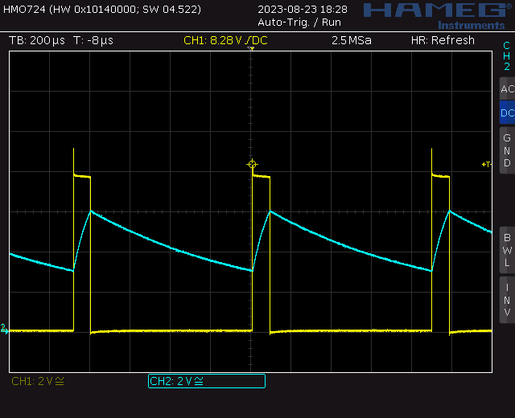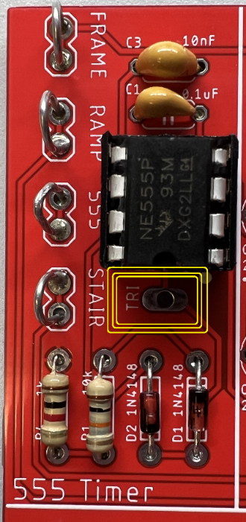

Figure : (Let) The TRI pin of the 555 Timer is available at the circled pad. Note, this oscilloscope trace was captured on a Rhode&Schwarz HMO724.

1. Take a screen shot of the two waveforms and include in your lab report. Screen shot the oscilloscope traces on USB. Cell phone pictures will lose points.  
   [Save] → Save → Format → 24-bit Bit... (*.bmp) [Save] → Save → Press to Save

## Debugging 555 TIMER Subsystem

Compare to the POWER INPUT subsystem, there are many more ways to foul up the 555 TIMER subsystem. If your BJT curve tracer board fails one of the test steps in the previous section, I will provide some guidance on what may have happened and how to correct it.

1. If the green LED is no longer illuminating when you apply power to the BJT curve tracer:
   * Verify you are applying power to the BJT curve tracer by probing the +9V and Gnd test points with a DMM in voltage mode and with the ON/OFF switch in the ON position.
   * Verify the ON/OFF switch is in the ON position.
   * Check the orientation of the 555 Timer IC.
2. If the 555 Timer is not generating a proper waveform:
   * Make sure the 555 TIMER parts are inserted in the correct location.
   * Check the orientation of all the 555 TIMER parts.